

**Software Engineering**

**Project Review-3**

**Topic: Online College Admission Management System**

**Group Members:**

19BCE0215-Vibhu Kumar Singh

19BCE0568-Anamaya Vyas

19BCE0634-Avnish Tiwari

**Submitted To:** Ushus Elizebeth Zachariah

**Abstract:**

Finding college after 12th is a hectic process, which involves students visiting various sites, some with verified information, some with not and taking a lot of precious time from the lives of the students. 0n the day of admission, the flow of candidates is very high and it requires both manual processing and record keeping at the same time that makes the process lengthy and difficult to keep track of the admission status of a candidate in multiple departments. At present the admission process is done manually with pen and paper which is very inefficient and utilizes much effort and time. This college admission management system helps to make the admission process much easier and helps in maintaining databases in an efficient way. In this system college admin can add the college details and the stream details. We can get the previous year’s cut off marks for all the streams. Colleges can create the cut off list for the current year and the students are expected to register on the website and apply for the desired stream. Colleges can register admissions of new students and also remove the students who are denied admission.

**1. Introduction**

Traditional college admission is a hectic process, which involves students visiting off-site campus, taking an application, filling it and then submission is another hectic story. 0n the day of admission, the flow of candidates is very high and it requires both manual processing and record keeping at the same time that makes the process lengthy and difficult to keep track of the admission status of a candidate in multiple departments. At present the admission process is done manually with pen and paper which is very inefficient and utilizes much effort and time. This college admission management system helps to make the admission process much easier and helps in maintaining databases in an efficient way. In this system college admin can add the college details and the stream details. We can get the previous year’s cut off marks for all the streams. Colleges can create the cut off list for the current year and the students are expected to register on the website and apply for the desired stream. Colleges can register admissions of new students and also remove the students who are denied admission.

**1.1 Motivation**

In the last moments of college admission people can get confused about where they can find a systematic overview of all the colleges and about their facilities with the placement criteria. Our website will be an aid to young students as it is having all the data compiled at one place.

**1.2 Aim of the proposed Work**

The aim of this project is to provide better services and facilities to the colleges as well as to students by making a platform where all colleges can come together and help the student to find the right college

**1.3 Objective(s) of the proposed work**

● Helping the students in selecting the college.

● Making an exam calendar for the students to keep track of all the exams and not forget.

about an exam.

● Containing the details about different colleges like placements, amenities, cutoff etc.

● Helps the students in taking admission by providing the links of the college and

application form.

Out of Scope-

● Cannot get selected into the college directly.

● Cannot recommend a suitable college for a student.

**1.4 Report Organization**

This research work is organized into five chapters.

Chapter one is concerned with the introduction of the research study and it presents the preliminaries, theoretical background, statement of the problem, aim and objectives of the study, significance of the study, scope of the study, organization of the research and definition of terms.

Chapter two focuses on the literature review, the contributions of other scholars on the subject matter are discussed.

Chapter three is concerned with the system analysis and design. It presents the research methodology used in

the development of the system. It analyses the present system to identify the problems and provides information on the advantages and disadvantages of the proposed system. The system design is also presented in this chapter.

Chapter four presents the system implementation and documentation, the choice of programming language. analysis of modules, choice of programming language and system requirements for implementation.

Chapter five focuses on the summary constraints of the study

Chapter six focuses on conclusion and recommendations are provided in this chapter based on the study carried out.

**2. Literature Survey**

[1] A Research Paper on College Management System.- Lalit Mohan Joshi, International Journal of Computer Applications ,Volume 122 – No.11, July 2015

[2] Web Based Student Information Management System- S.R. Bharamagoudar1, Geeta R.B.2, S.G.Totad, International Journal of Advanced Research in Computer and Communication Engineering Vol. 2, Issue 6, June 2013

[3] Advanced Embedded System Assisted Gsm and Rfid Based Smart school Management System.V. Sivasankaran, S.Muruganand, Azha. Periasamy international Journal of Advanced Research in Electrical, Electronics And Instrumentation Engineering Vol. 2, Issue 7, July 2013.

[4] N. M. Z. Hashim and S. N. K. S. Mohamed, “Development of Student Information System” University Teknikal Malaysia Melaka, vol. 2, pp. 256 - 260, August 2013.

[5].Srikant Patnaik1, Khushboo kumari Singh2, Rashmi

Ranjan3, Niki Kumari4 “College ,management system”,

International ResearchJournal of Engineering and

Technology (IRJ Volume:03Issue:05/May-2016.

**2.1. Survey of the Existing Models/Work**

This paper [1] is aims to develop an Online Intranet College Management System (CMS) which is useful to any education institution. The system (CMS) is an Intranet based application that can be accessed throughout the institution or a specified department. This system aims to monitor the attendance of students for the college.Anyinformation regarding college is accessible to students as well as staff members. The staff uploads their and students attendance and also the marks of the students are maintained. Easy access to information is given to registered users.CMS aims to provide information to all the levels of management in any institution. Student Information Management System (SIMS) aims to provide an interface to maintain student information.

Educational institutes or colleges can use this system to maintain information of students. The Student information system maintains all kind of details regarding students, college, course, batch, placements, academic progress report and other resource related details too. Student details can be tracked from day one to last day which can be useful to maintain records.

**2.2. Summary/Gaps identified in the Survey**

Global systems for mobile communication is considered as the reliable and efficient technology for most of the technological devices. GSM used is to know the information about the student whereabouts and his activities completely. The RFID is used to integrate the parts of the student in order to track the student there itself.

Information system is useful in accessing student’s data from anywhere and anytime. It is one of the userfriendly ways of accessing information. Many organizations spend alot of cost in developing such information systems for the reliability in their organization. This project develops student information system which focusses on recording, storing and updating the student details. The new system uses the Rapid Application Development model for the software development. The database will be storing all the student records. This system provide ease to the users as well as professor for arranging the lectures.

The system provides guidance to the admin to keep track of each student. The admin have the access to the database of system .In an educational institute management is crucial thing. So in order to reduce the efforts of staff we are introducing our system. The system comes on with much functionality like voting event details, feedback, news line etc. It provides a additional feature newlines that helps the student to get department newlines and reports (achievements, toppers).It also provide the voting feature so that manual work is reduced. This system is paperless system. System provides functionality for student to application where in admin can manage ,student can access uploaded notes, course details. Student will get the event details through sms. Overall manpower and reduces the time required.

**3.Proposed System Requirements Analysis and Design**

**3.1. Introduction**

**Questionnaire**

1. Are system requirements allocated to software used to establish a baseline for software engineering and management use?

Ans. Yes.

1. Are estimates (e.g. size, cost, and schedule) documented for use in planning and tracking the software project?

Ans. Yes, because without estimates our software will not develop before the given deadline.

1. Are software quality assurance (SQA) activities planned?

Ans. It is organizational software so the answer is obviously yes to build a good quality software.

1. Has your organization developed and does it maintain a standard software process?

Ans. Yes.

1. Does your organizational policy allow you to update or modify the software by taking user feedback?

Ans. No.

1. Are the activities for managing software quality planned for the project?

Ans. Yes.

1. Does the new technology have some effect on quality and productivity?

Ans. Obviously Yes, but we are making component based software so any changes can be managed easily.

1. How much pressure does it put on you to develop a cost effective, reliable software in a limited amount of time and how do you handle this?

Ans. Not very much, because we will not include any unnecessary features so that it will be cost effective and developed in a given time.

**3.2 Requirement Analysis**

Requirement Analysis, also known as Requirement Engineering, is the process of defining user expectations for a new software being built or modified.

In systems engineering and software engineering, requirements analysis focuses on the tasks that determine the needs or conditions to meet the new or altered product or project, taking account of the possibly conflicting requirements of the various stakeholders, analyzing, documenting, validating and managing software or system requirements.

**3.2.1 Stakeholder Identification**

College Universities

Students

Parents

Coaching institutes

**3.2.2 Functional Requirements**

**Registration:**

REQ-1: Data updation

REQ-2: Detail filling

REQ-3: Data verification

**Sorting:**

REQ-1: Data Sorting

REQ-2: List of sorted data visible in a organized manner

REQ-3: Interface to fill user’s choices

REQ-4: Multiple requirements taken care off

**Report:**

REQ-1: Filing problem

REQ-2: Stating the issue

**Admin:**

REQ-1: View data

REQ-2: View Users

REQ-3: Delete Users

REQ-4: View Reports

**3.2.3 Non-Functional Requirements**

**Registration:**

REQ-1: Data storage

REQ-2: Data security

REQ-3: HTTPS requests generated

**Sorting:**

REQ-1: SQL query usage

REQ-2: HTTPS protocol for contacting the server

REQ-3: Data Scrutiny

**Report:**

REQ-1: SQL query usage

REQ-2: HTTPS protocol for contacting the server

REQ-3: Data Scrutiny

**Admin:**

REQ-1: SQL query usage

REQ-2: HTTPS protocol for contacting the server

REQ-3: Data Scrutiny

**3.2.4 System Requirements**

To be used efficiently, all computer software needs certain hardware components or other software resources to be present on a computer. These prerequisites are known as system requirements and are often used as a guideline as opposed to an absolute rule

**3.2.4.1. H/W Requirements(details about Application-Specific Hardware)**

Intel Core 5(i5-10400)

Frequency base 2.9 GHZ

RAM 512 MB or more

**3.2.4.2. S/W Requirements(details about Application-Specific Software)**

Operating system-We have chosen Windows operating system for its best support and user-

friendliness.

Database-To save the students and college information we have chosen SQL database.

Language-To implement the project we have chosen Python language for its robustness and

its interactive support.

**3.2.5 Software Requirement Specification Document**

1.Introduction

Traditional college admission is a hectic process, which involves students visiting off-site campus,

taking application, filling it and then submission is another hectic story. 0n the day of admission, the

flow of candidates is very high and it requires both manual processing and record keeping at the

same time that makes the process lengthy and difficult to keep track of the admission status of a

candidate in multiple departments. At present admission process is done manually with pen and

paper which is very inefficient and utilizes much efforts and time. This college admission

management system helps to make the admission process much easier and helps in maintaining

database in an efficient way. In this system college admin can add the college details and the stream

details. We can get the previous year’s cut off marks for all the streams. College can create the cut

off list for the current year and the students are expected to register on the website and apply for the

desired stream. College can register admissions of new students and also remove the students who

denies the admission.

1.1 Purpose

The purpose of this document is to retrieve and analyze the ideas that define the product and

requirements that the user needs. This document describes the details of our product, its parameter,

and its goals. This SRS document describes the target, audience, user interface of product and

Software/Hardware requirements of our product. This document also describes the problem we have

faced during the designing and implementation of the product and also describes how we have

solved this problem and make our product more efficient.

The management system saves the human power and time cost to perform the same task. The data

in the database can be saved for a long time and can be used for different purposes in the future. In

management systems, there is a minor chance of losing the data. This document also defines how

customers and users see our product and understand the functionality of the product. This document

will help the developers/designers in case of maintenance of the software product.

1.2 Document Conventions

Items that are intended to stay in as part of your document are in bold.

Explanatory comments are in italic text.

Plain text is used where you might insert wording about your project.

1.3 Intended Audience and Reading Suggestions

This document is to be read by the development team, the project managers, marketing staff, testers,

and documentation writers. The software engineer/Developer and project managers need to become

intimately familiar with the SRS. Others involved need to review the document.

Testers need an understanding of the system features to develop meaningful test cases and give

useful feedback to the developers. The developers need to know the requirements of the software

product they need to build.

This document is for general discussions on the implementation decisions regarding the College

Management System. The user of the product should have the concepts of RDMS, SQL, interfaces,

and classes.

1.4 Product Scope

● Helping the students in selecting the college.

● Making an exam calendar for the students to keep track of all the exams and not forget

about an exam.

● Containing the details about different colleges like placements, amenities, cutoff etc.

● Helps the students in taking admission by providing the links of the college and

application form.

Out of Scope-

● Cannot get selected into the college directly.

● Cannot recommend a suitable college for a student.

1.5 References

https://shsu-ir.tdl.org/shsu-ir/bitstream/handle/20.500.11875/1164/0781.pdf?sequence=1

https://ieeexplore.ieee.org/document/6208293/

https://ieeexplore.ieee.org/document/4679917/

2. Overall Description

2.1 Product Perspective

The web pages (HTML) are present to provide the user interface on user(Students and College)

interface side. Communication between users and server is provided through HTTP/HTTPS

protocols.

The Client Software is to provide the user interface on system user client side and for this TCP/IP

protocols are used.

On the server side web server is EJB and database server is for storing the information.

2.2 Product Functions

Some of the features are identified for the software. They are listed below:

• College Details updation: The college can update their details after giving the details once

any details that they give like fees , average CTC etc is bound to change in near future,

which they can update.

• Data encryption: Data protection and security is one of the most important aspect of the

current times for saving every account’s details(Student and College) we encrypt the

passwords and usernames so that hacking into system becomes impossible.

• Email verification: Who can verify yourself other than you. Keeping that in mind the

product will have an email verification system, Forgot password and registration would

require email verification.

• Sort: Every Student has his own requirements and constraint. Keeping that in mind the

product will ask the students the different parameters on which he wants to find a college,

the system will sort the data accordingly and give you the result.

• Fraud protection: E-Frauds are quite common these days and to protect our customers

from this we made a report feature too, in this the customers can report any info or

account/user and the administration will verify the reports made by the customers

2.3 User Classes and Characteristics

The Student and College Admins should have the basic idea to operate (use) the system and

he already has the experience to work in the internet (browser).

Default Language is English.

Some of the users identified for this system through use case analysis are listed below:

Students

Data entry operators

College Administrators

Product Administrators

2.4 Operating Environment

The CMS is expected to be deployed in a real environment to manage the DBMS inside the college.

The centralized database is used to store the information. The user only within the college

(members of college staff) can use this management system. Users outside form the college cannot

access the management system. This application is developed for windows operating system that

can be run on Windows XP and above.

The database is used in different departments within a branch of the college. The database used to

store the information is the centralized database. The software we have developed will be installed

on different computer systems within a college and software will be connected to a centralized

database through LAN within a college and then the user can interact with the system and can store

the data and other users can get access the stored through a centralized database.

2.5 Design and Implementation Constraints

Some of the design and implementation constraints identified are listed below:

• Students are not allowed to enter any data entry from College interface.

• Neither Student Nor College has any rights to edit any data in the system.v

• Student can only report an account but its removal is totally lies in the hands of the

administration.

2.6 User Documentation

Online documentation facility is available for the students to assess them for the easy use.

A specific document should be prepared for the maintenance of the system and should say

the system in easiest way.

2.7 Assumptions and Dependencies

College details fields are already added Databases are already created Data encryption is already present Administrator is already created.

3. External Interface Requirements

3.1 User Interfaces

The user interface for this system will have to be simple and clear. Most importantly, the

Information must be easy to read, easy to understand and accessible. The color scheme should be

appropriate to provide familiarity there should be no contrast

issues.

The interface would have to be super easy to use and be accessible as well so that the students do

not face any problems in navigating through the website.

3.2 Hardware Interfaces

Intel Core 5(i5-10400)

Frequency base 2.9 GHZ

RAM 512 MB or more

3.3 Software Interfaces

Operating system-We have chosen Windows operating system for its best support and user-

friendliness.

Database-To save the students and college information we have chosen SQL database.

Language-To implement the project we have chosen Python language for its robustness and

its interactive support.

3.4 Communications Interfaces

Client on Internet will be using HTTP/HTTPS Protocol.

Client on intranet will be using TCP/IP protocol.

4. System Features

4.1 Registration

4.1.1 Description and Priority

Every college one the time of the login will get a form for filling key points about their college, these

key point can be like average CTC, courses they are providing, location etc. Some of the values can

remain same but other tend to vary with time for eg: average CTC, NIRF ranking, courses college is

proving. For this the product will give the college an option to update the details after entering them

for the first time. It is a very important aspect of our product and on a scale of 1 to 10 the priority of

this feature is 9.

4.1.2 Stimulus/Response Sequences

After filling the details for the first time the data will be visible on the student dashboard and the

student can surf and sort data as per will, the college dashboard will also the data on its own home

page and a small button of updating at the bottom which will allow it to direct itself to the updating

page which will allow the college interface to update data as per will. After updation, the data will be

changed on database and changes will be reflected on the user interface accordingly.

4.1.3 Functional Requirements

REQ-1: Data updation

REQ-2: Details filling

REQ-3: Data verification

4.1.4 Non-Functional Requirements

REQ-1:Data storage

REQ-2:Data security

REQ-3:HTTPS requests generated

4.2 Sorting

4.2.1 Description and Priority

Every student will be able to sort the colleges as per will and the requirements of their own, for eg a

student might want a college with less fee, closer location or both. This feature allows the student to

compare different colleges with very precise information at just one click. This is one of the salient

features of our product and it’s a very high priority feature. On a scale of 1 to 10 its priority is 10.

4.2.2 Stimulus/Response Sequences

Complex SQL queries will be used in this features so the stimulus might be a little delayed as data

will be searched to provide the best results and with a large database it might take 5-10 seconds. After

the sorting the data suitable to the query and requirements will be visible on the user interface which

will allow the student to check and compare all the colleges as per will and which suites him the most.

4.2.3 Functional Requirements

REQ-1: Data Sorting

REQ-2: List of sorted data visible in a organized manner

REQ-3: Interface to fill user’s choices

REQ-4: Multiple requirements taken care off

4.2.4 Non-Functional Requirements

REQ-1:SQL query usage

REQ-2:HTTPS protocol for contacting the server

REQ-3:Data Scrutiny

4.3 Report

4.3.1 Description and Priority

E-Frauds are one of the most common things these days and if a student thinks that some college is

providing fraud data the can report the college by themselves and later the product administrative

the committee can take the appropriate actions thus we can be sure that no fraud takes place. As The

colleges these days are very careful for their reputation and the monitoring of data will be done while

registration this feature’s priority is not that much. On a scale of 1-10 it can be around 5.

4.3.2 Stimulus/Response Sequences

The report will be saved in the database and the administration will be able to check the

problems posted by the students and they can take appropriate action. The results of the

action will be visible few days after the complain after scrutinizing the issues posted by the

user.

4.3.3 Functional Requirements

REQ-1: Filing problem

REQ-2: Stating the issue

4.3.4 Non-Functional Requirements

REQ-1:SQL query usage

REQ-2:HTTPS protocol for contacting the server

REQ-3:Data Scrutiny

4.4 Admin

4.4.1 Description and Priority

This interface is for the security purposes The admin interface will be hidden from the other users and

only few special personals would be able to open it. The admin will be able to see all the users

enrolled with the product He will also have the power to remove anyone from the database and can do

if he find anything fraudulent. The admin would also settle report queries and take appropriate action

accordingly. On a scale of 1-10 it can be around 10.

4.4.2 Stimulus/Response Sequences

The Admin would be able to see all people registered with the website and can delete them

and can settle report queries. The admin would be able to contact the database’s core and can

work with database. He will be using HTTPS queries for the same.

4.4.3 Functional Requirements

REQ-1: View data

REQ-2: View Users

REQ-3: Delete Users

REQ-4: View Reports

4.4.4 Non-Functional Requirements

REQ-1:SQL query usage

REQ-2:HTTPS protocol for contacting the server

REQ-3:Data Scrutiny

5.Other Nonfunctional Requirements

5.1 Performance Requirements

Some Performance requirements identified is listed below:

The database shall be able to accommodate a minimum of 10,000 records of students.

The software shall support use of multiple users at a time.

There are no other specific performance requirements that will affect development.

5.2 Security Requirements

Some of the factors that are identified to protect the software from accidental or malicious access,

use, modification, destruction, or disclosure are described below. Specific requirements in this area

could include the need to:

• Utilize certain cryptographic techniques

• Keep specific log or history data sets

• Assign certain functions to different modules

• Restrict communications between some areas of the program

• Check data integrity for critical variables

• Later version of the software will incorporate encryption techniques in the user/license

authentication process.

• The software will include an error tracking log that will help the user understand what error

occurred when the application crashed along with suggestions on how to prevent the error

from occurring again.

• Communication needs to be restricted when the application is validating the user or license.

(i.e., using https).

5.3 Software Quality Attributes

There are a number of attributes of software that can serve as requirements. It is important that

required attributes by specified so that their achievement can be objectively verified. The following

items provide a partial list of examples.

The input system will allow for inputting numbers, operands, special symbols and letters of

the alphabet.

6. Other Requirements

<NONE>

Appendix A: Glossary

College Details – A listing of the colleges on the website and the information about them like the

facilities, connectivity, courses offered, seat matrix and fee structure. This would help the students

in selecting the colleges.

Cutoff-In this section we will list some previous years cutoff of an exam or of college so that

students can see which colleges would they be eligible for and they can prepare for their colleges by

setting a target.

Exams List-In this we would like to make a calendar like something so that the student can

remember all of his exams its due date and its application form filling dates etc. so that he doesn't

miss any of the exams.

Student Details-In this section the student would fill his/her details and login and access through

site, also if any college wants to contact the student or vice versa the details would help and the

students as well as the college would benefit from it.

Appendix B: Analysis Models

ER Diagram:

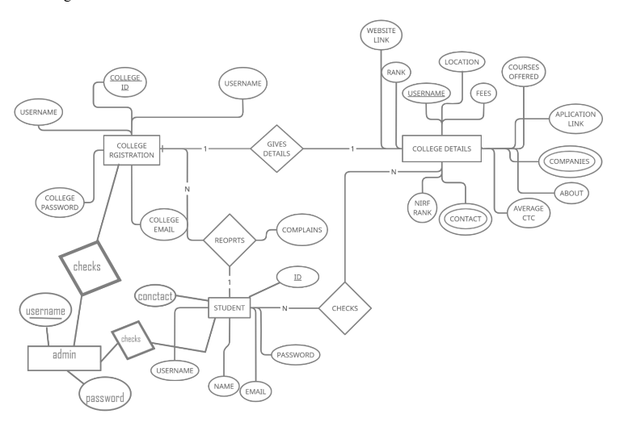

**3.2.6 Gantt Chart**

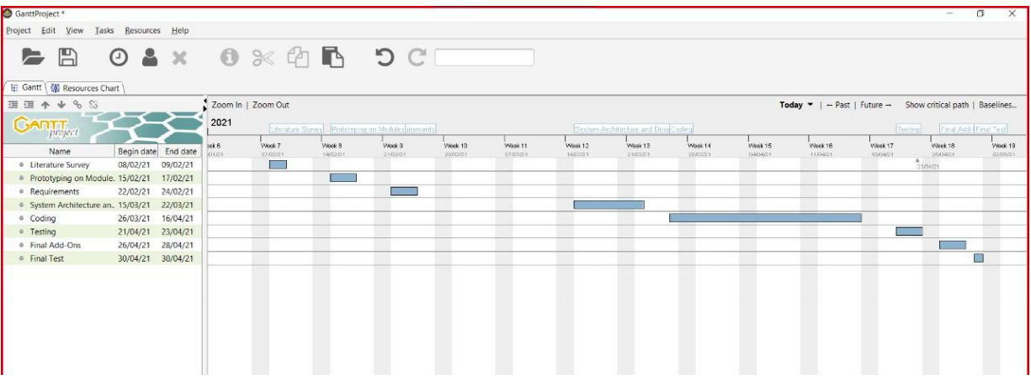

**4. Design of the Proposed System**

**4.1 Introduction**

The Process Model used in our project “College Management System” is a waterfall model.

**4.2 High level Design (Framework, Architecture or Module for the Proposed System(with explanation))**

The waterfall Model is a linear sequential flow. In which progress is seen as flowing steadily downwards (like a waterfall) through the phases of software implementation. This means that any phase in the development process begins only if the previous phase is complete. The waterfall approach does not define the process to go back to the previous phase to handle changes in requirement. The waterfall approach is the earliest approach that was used for software development.

● We use this model because of its Process visibility which helps to make our project easy.

● Also in the waterfall model there is a feature of Separation of tasks which divides the task into short phases of work and frequent reassessment and adaptation of plans.It helps in reducing difficulty of planning the project.

● No overlapping-In Waterfall, all the phases are linear therefore all the tasks are sequential and there is no chance for tasks to be overlapping.

● Extensive Documentation-All the steps, tasks, requirements as well each phase are extensively documented. This helps to audit project artefacts easily. Each phase has specific deliverables.

● Another plus point in using a waterfall model is that it is also very cost efficient.

**4.2.1 Architecture design**

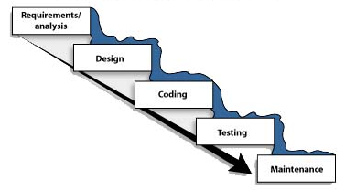

**4.2.2. Architecture diagram**

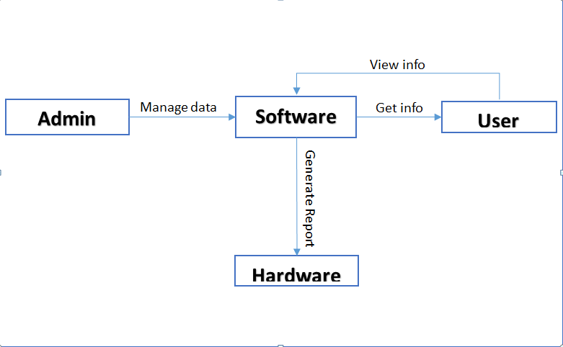

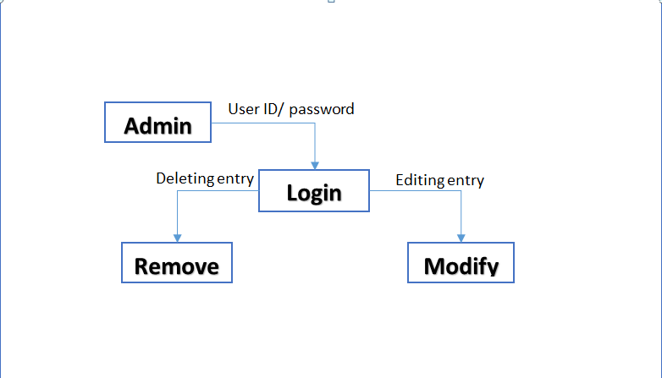

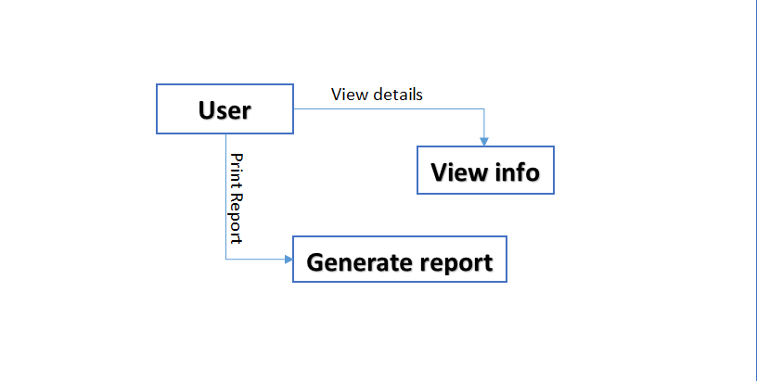

**4.2.3 UI Design**

User Interface Design is a process of designing or fabricating the interfaces through which the user can communicate with the computer.

The user interface for this system will have to be simple and clear. Most importantly, the Information must be easy to read, easy to understand and accessible. The color scheme should be appropriate to provide familiarity. There should be no contrast issues. The interface would have to be super easy to use and be accessible as well so that the students do not face any problems in navigating through the website.

**4.3 Detailed Design (ER Diagram/UML Diagram/Mathematical Modeling)**

**4.3.1 ER Diagram**



**4.3.2 UML Diagrams**

**Class Diagram:-**

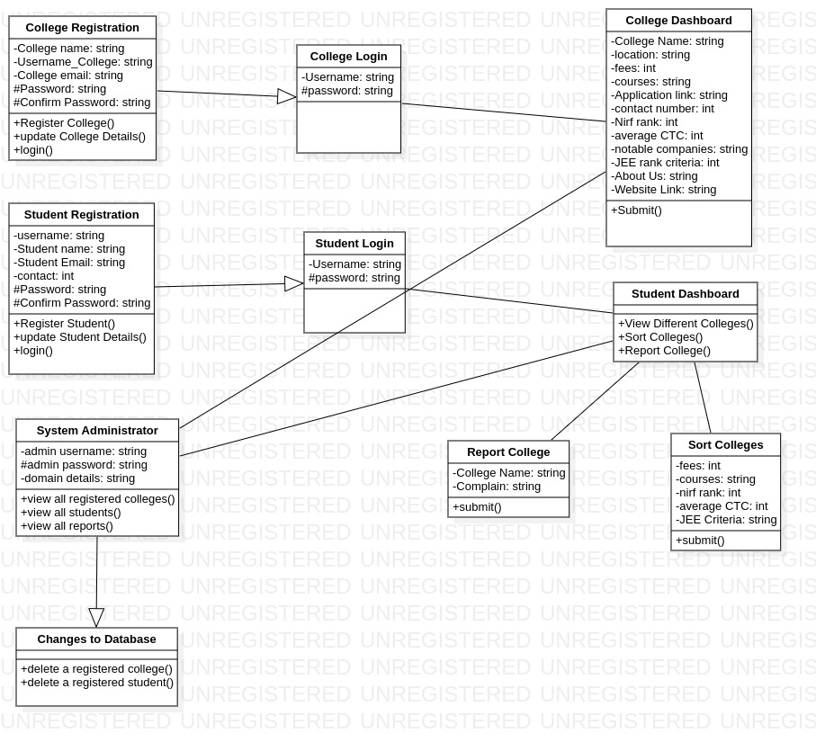

**Activity Diagram:**

College User:

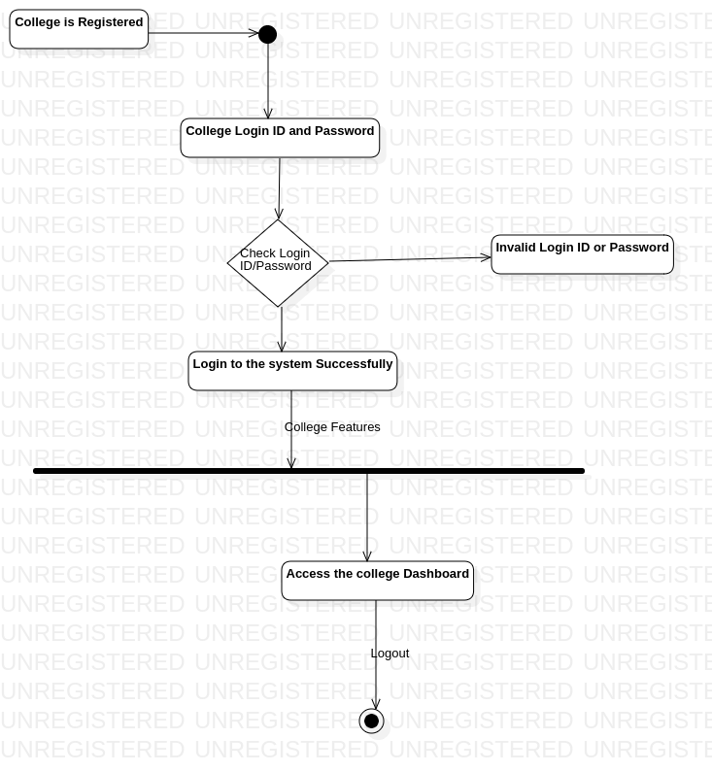

Student User:

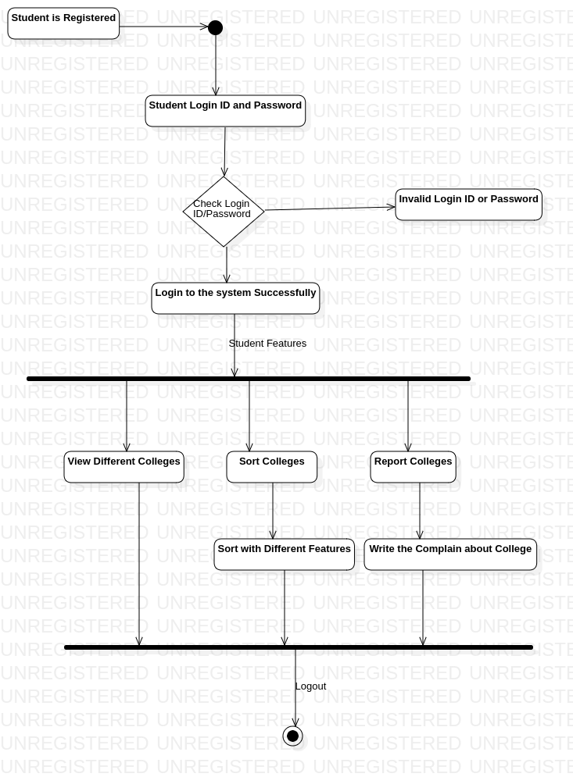

Admin:

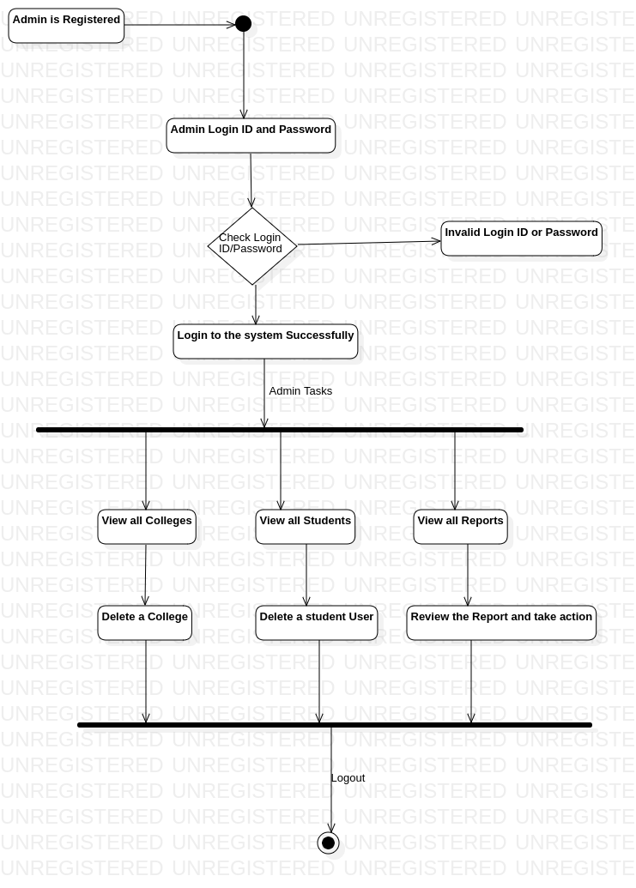

**Sequence Diagram:**

College User: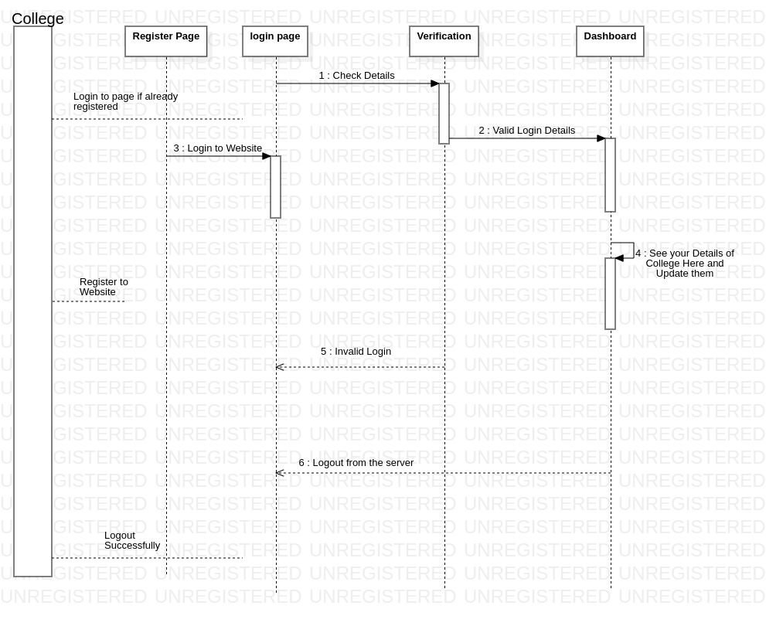

Student User:

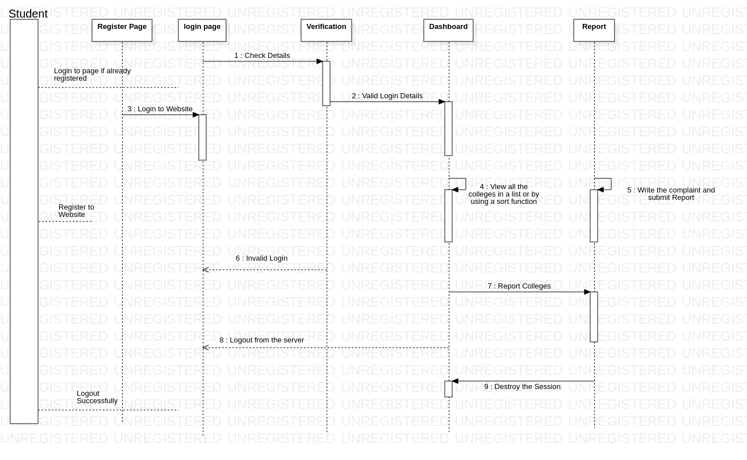

Admin:

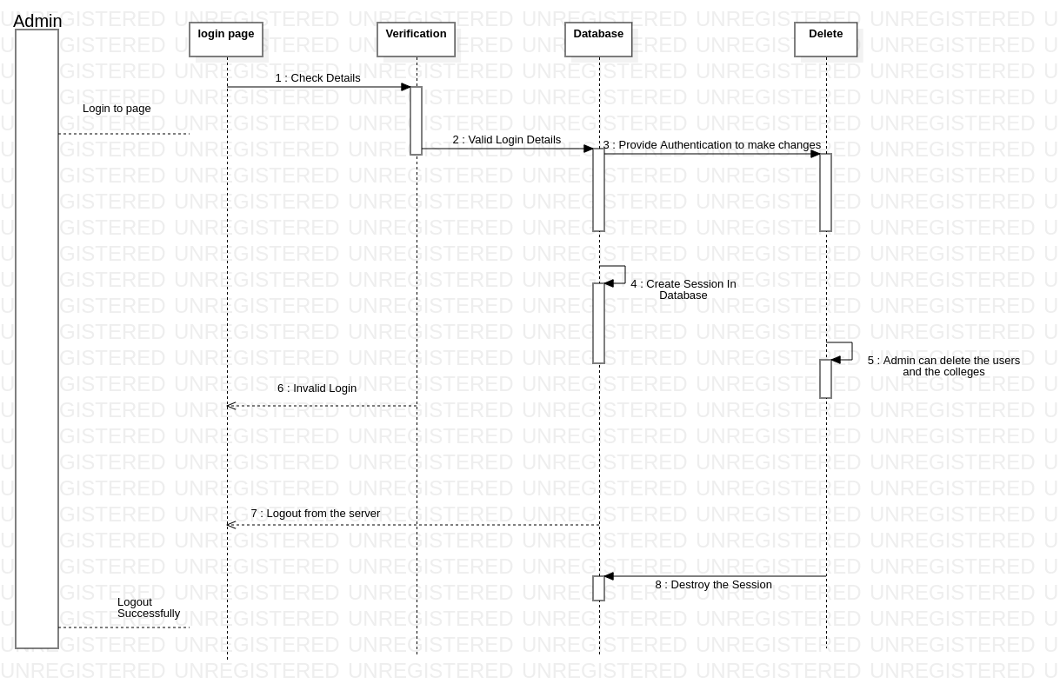

**5. Implementation and Testing**

**5.1 Implementation details**

**Student Module:**

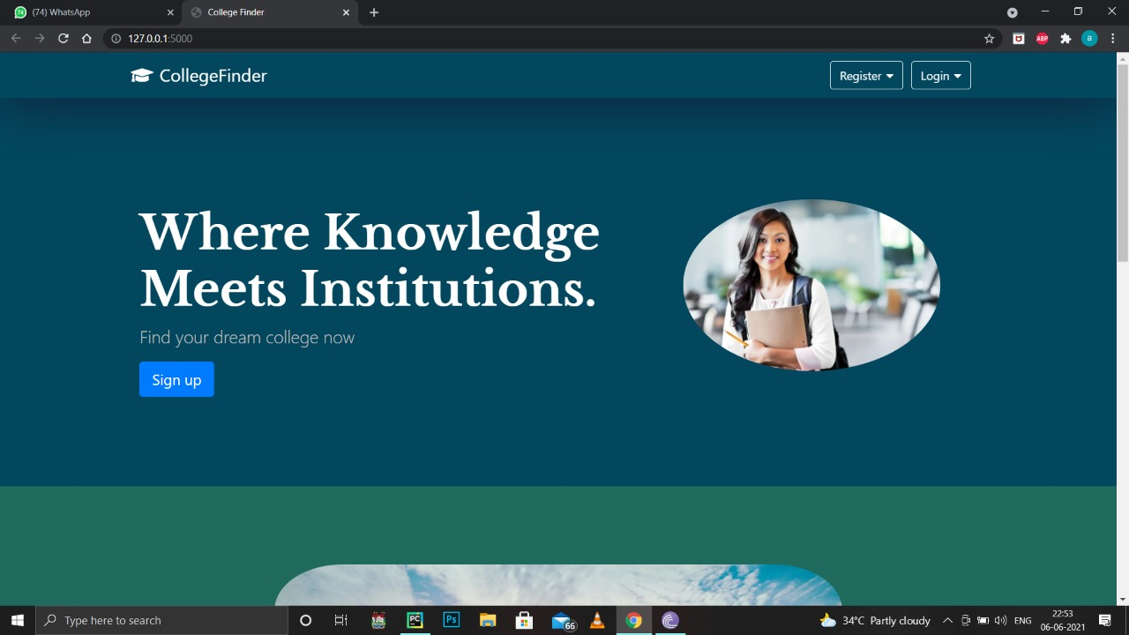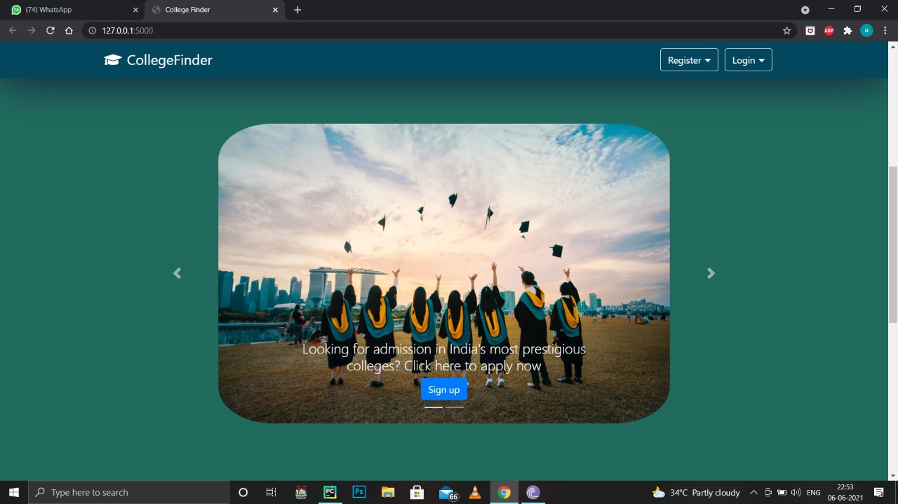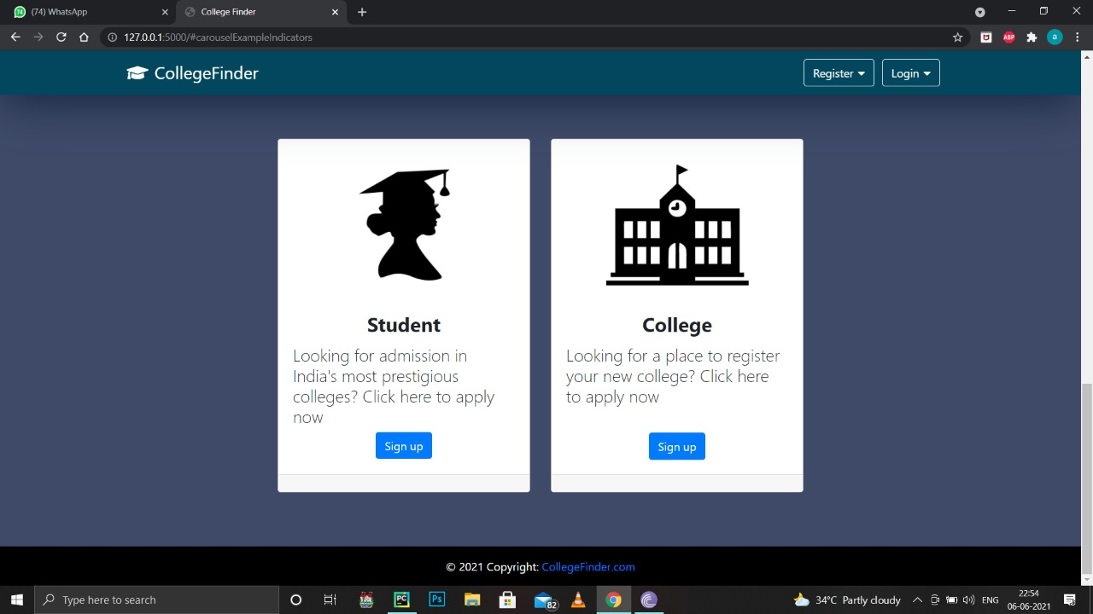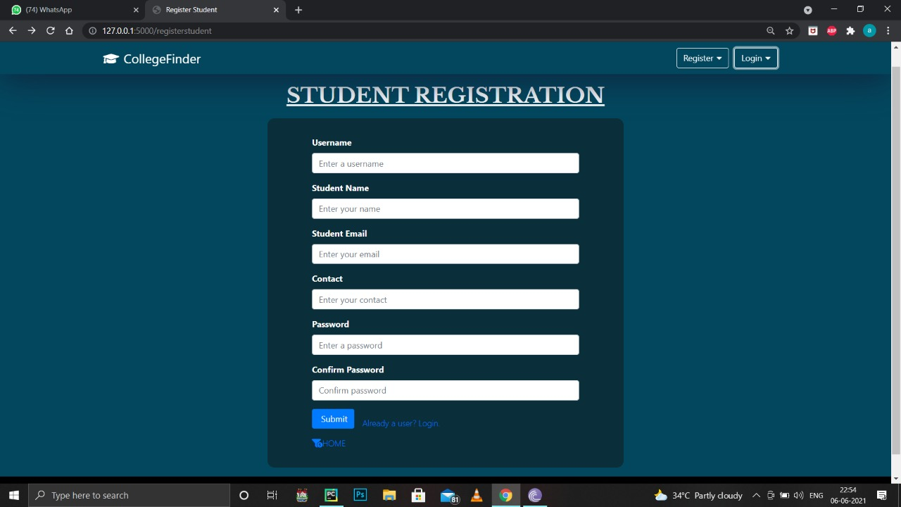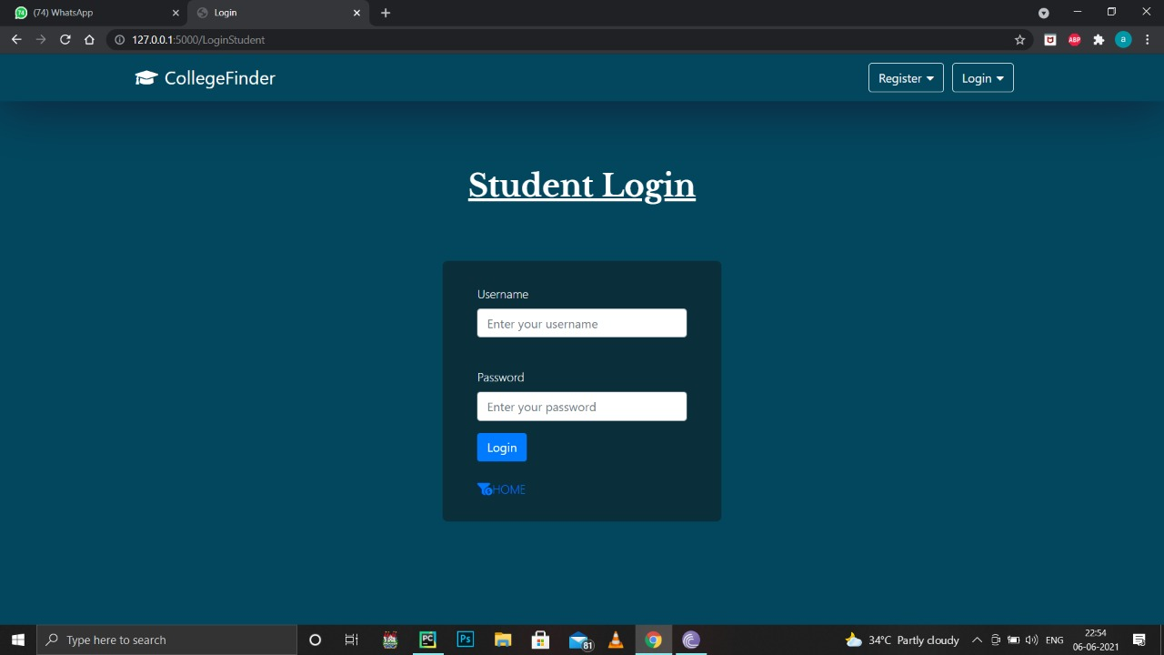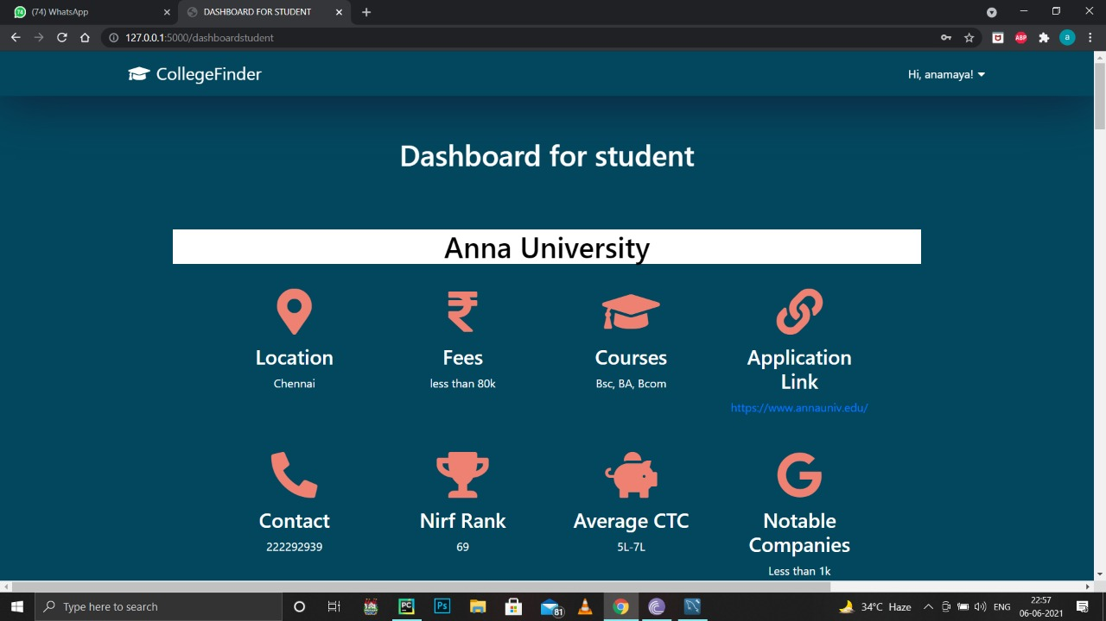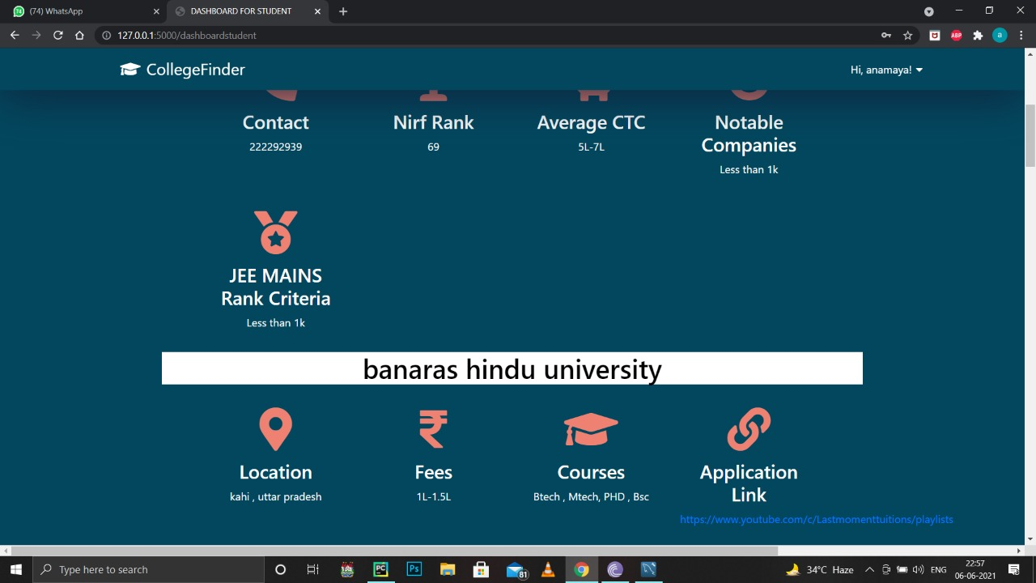

**Sorting colleges:**

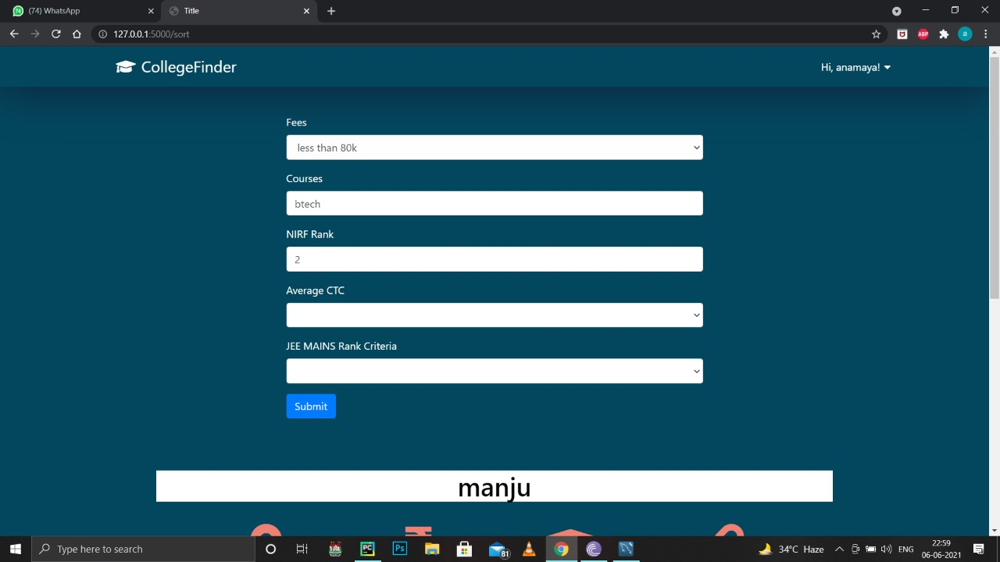

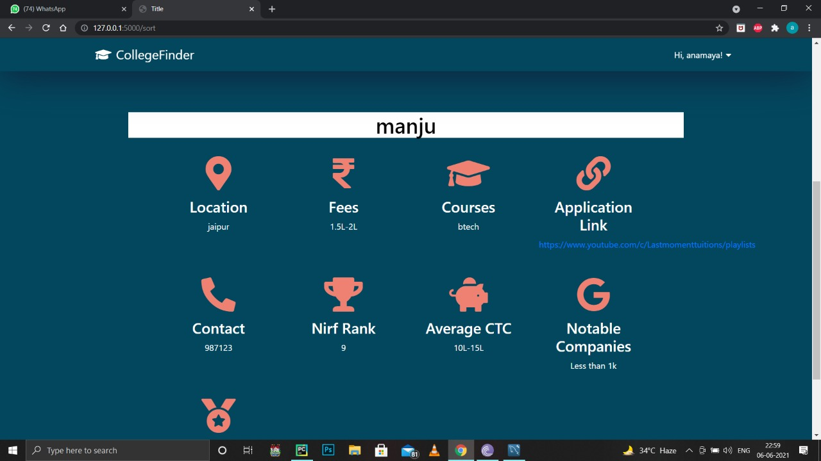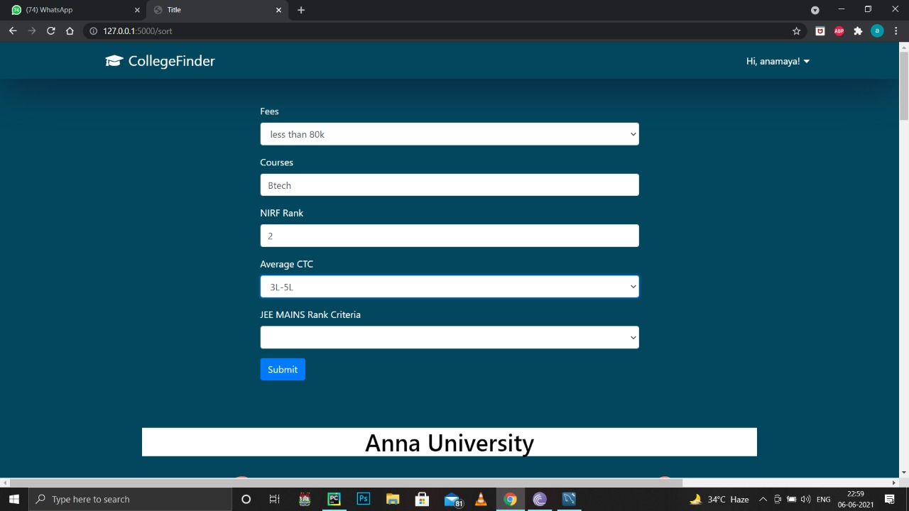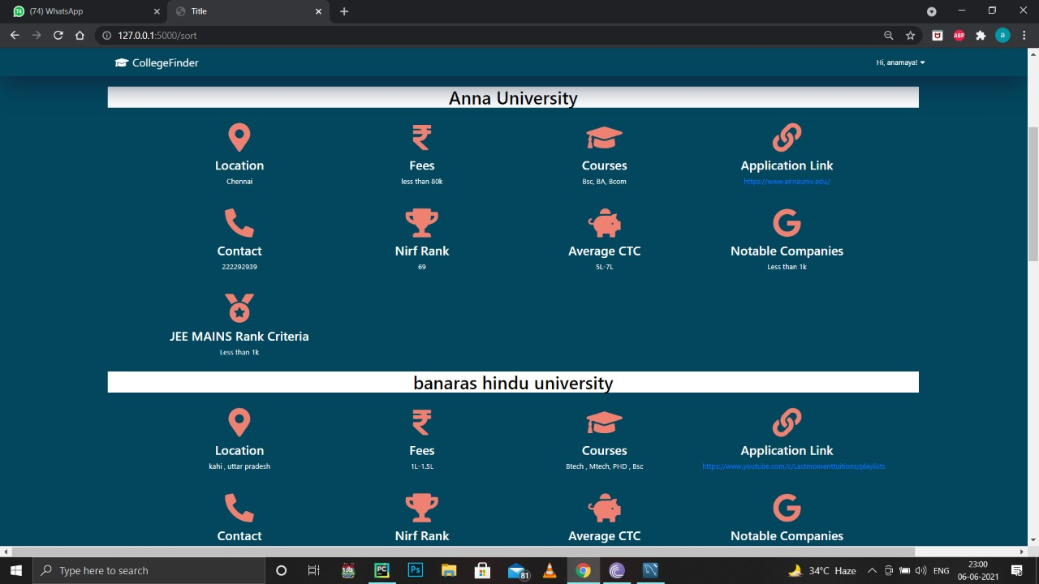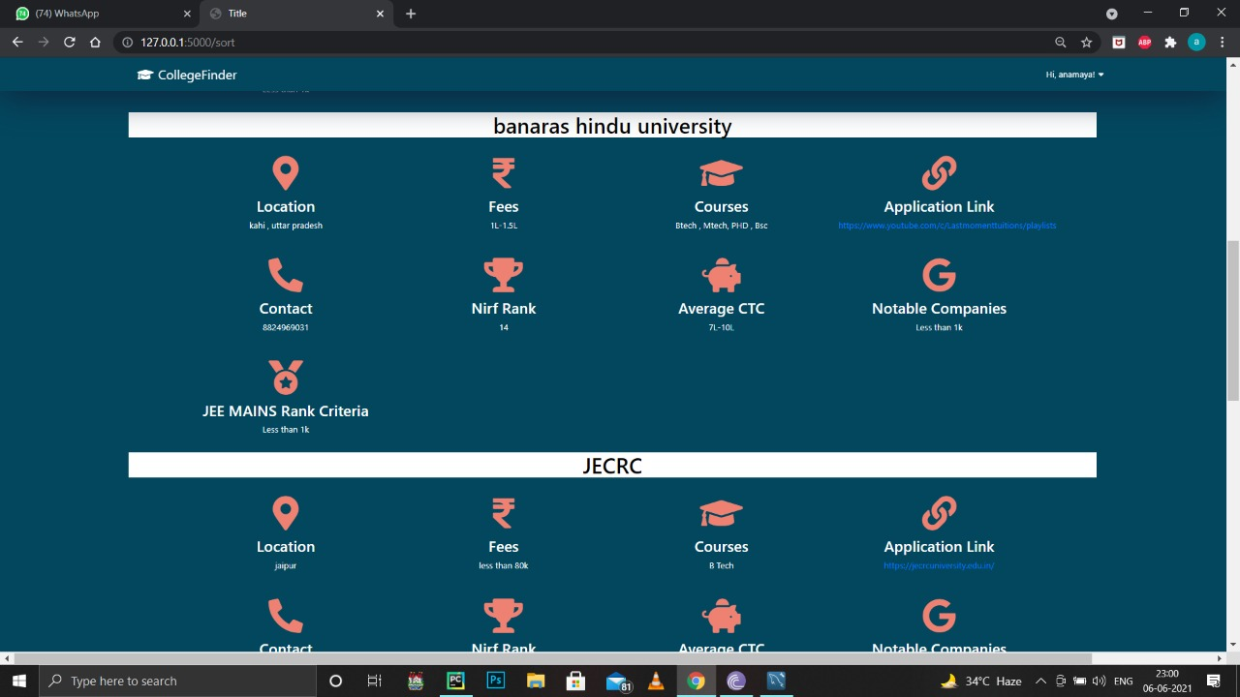

**Report colleges:**

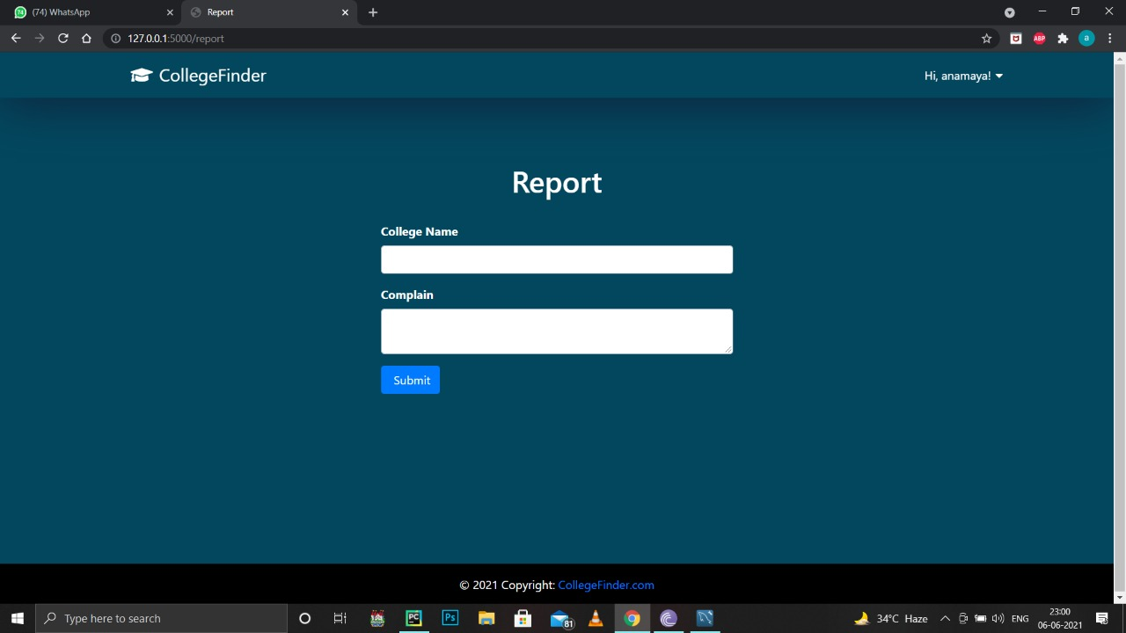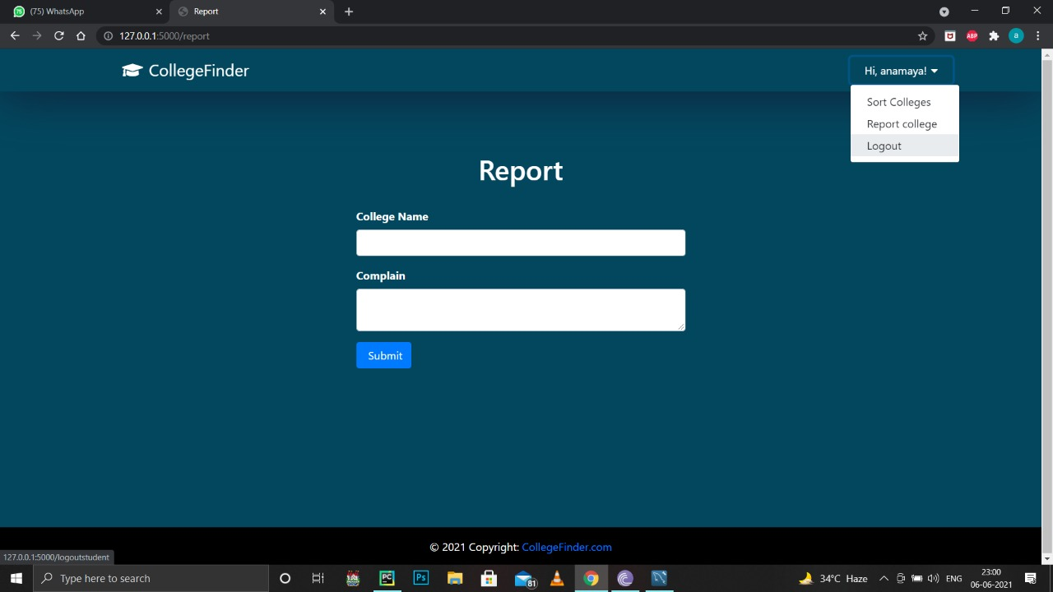

**College Module:**

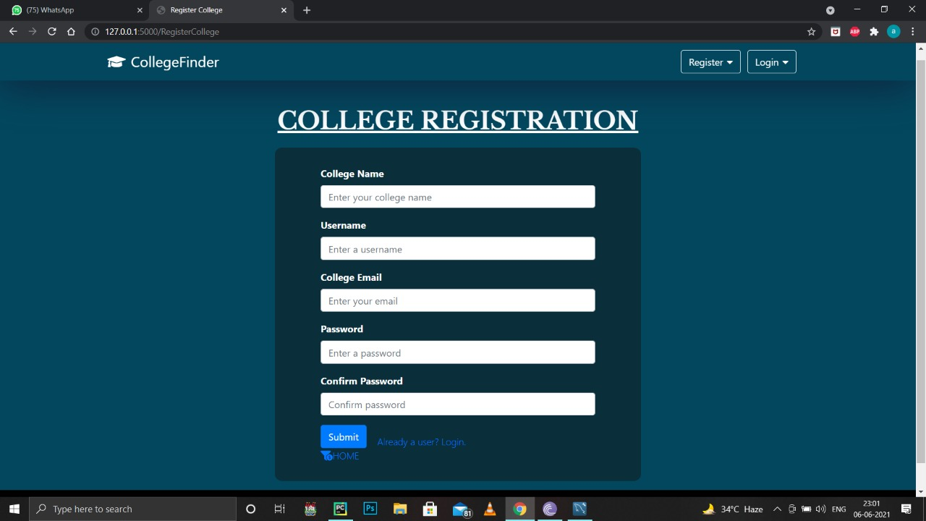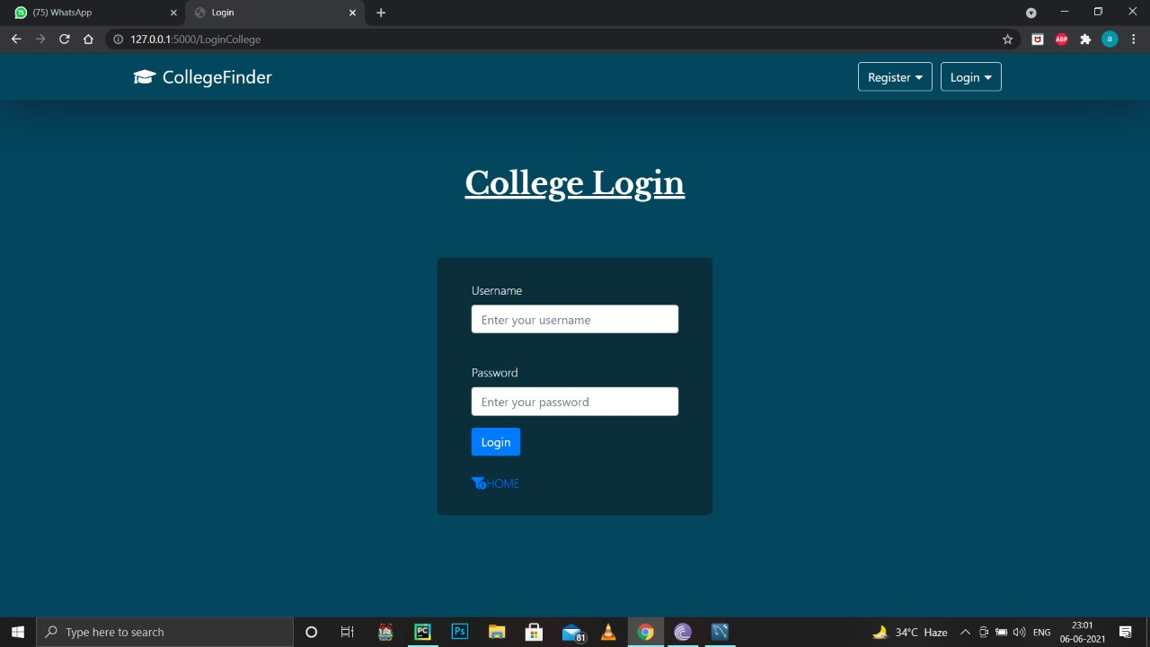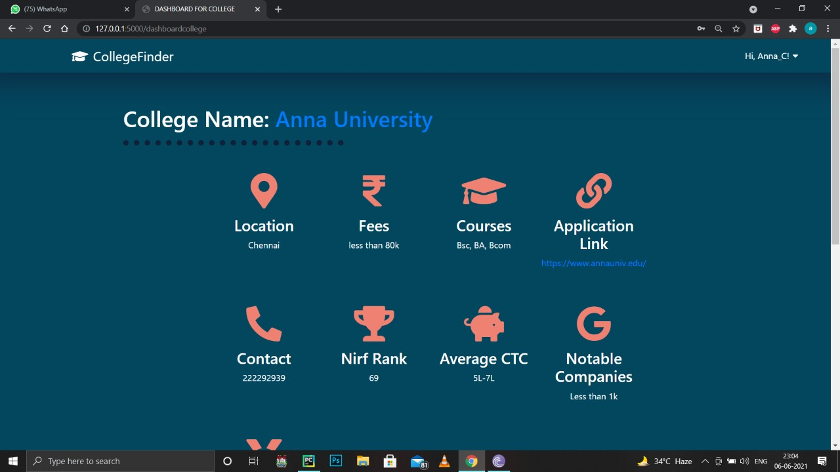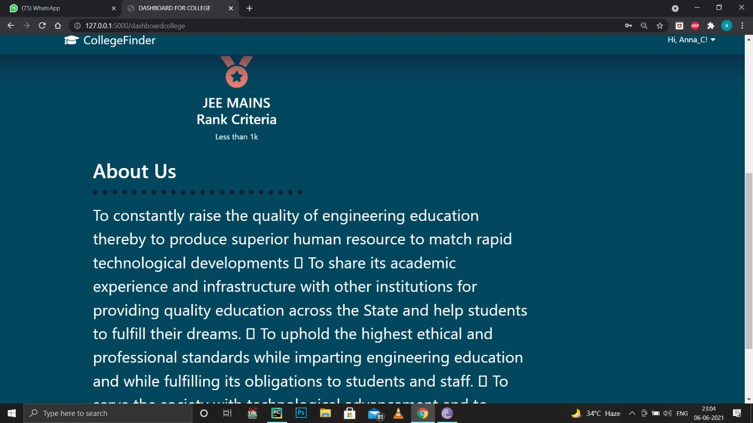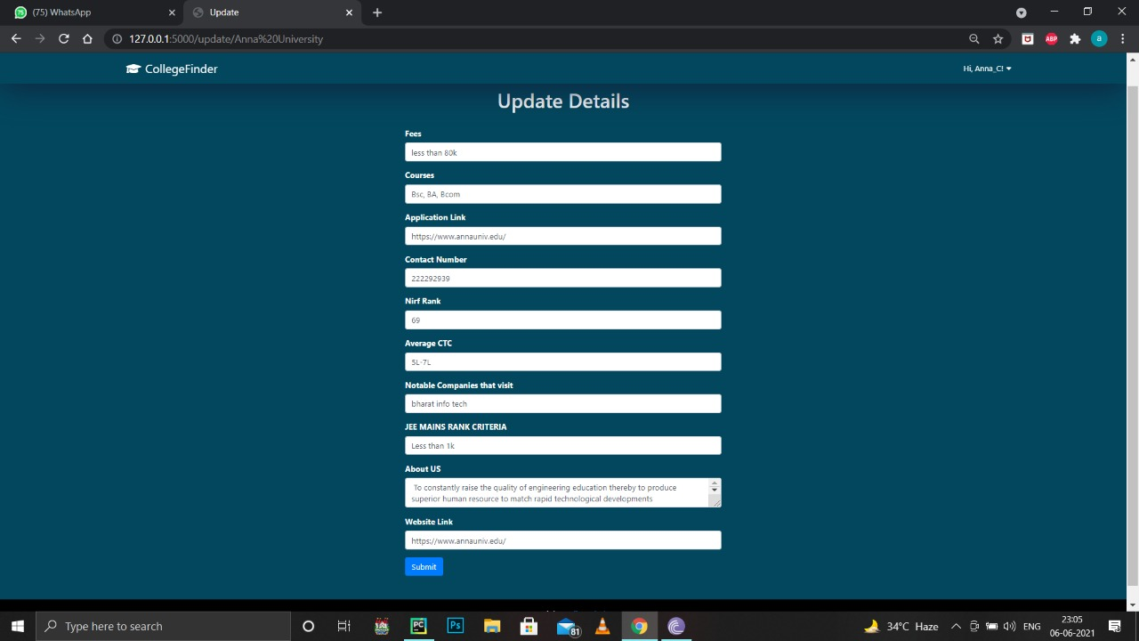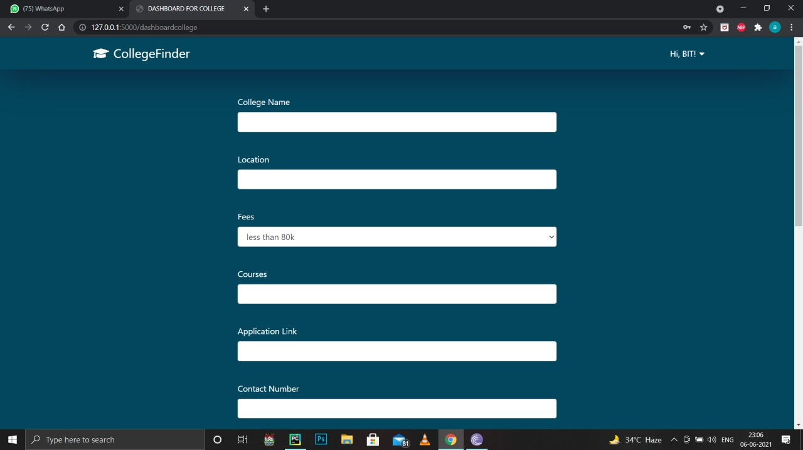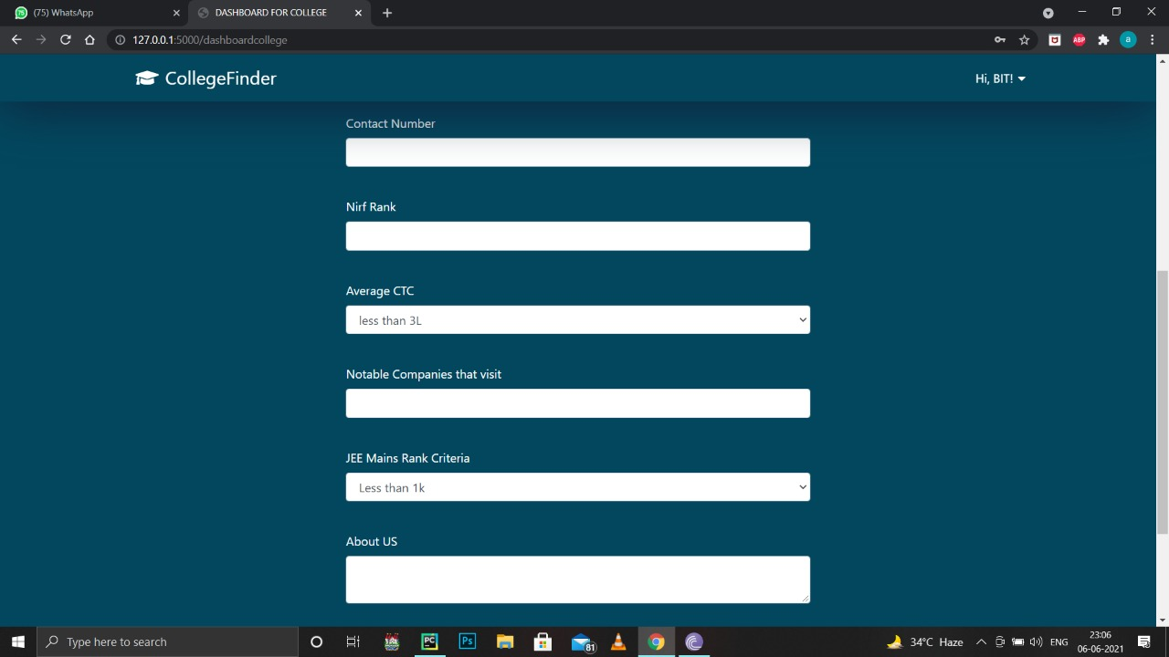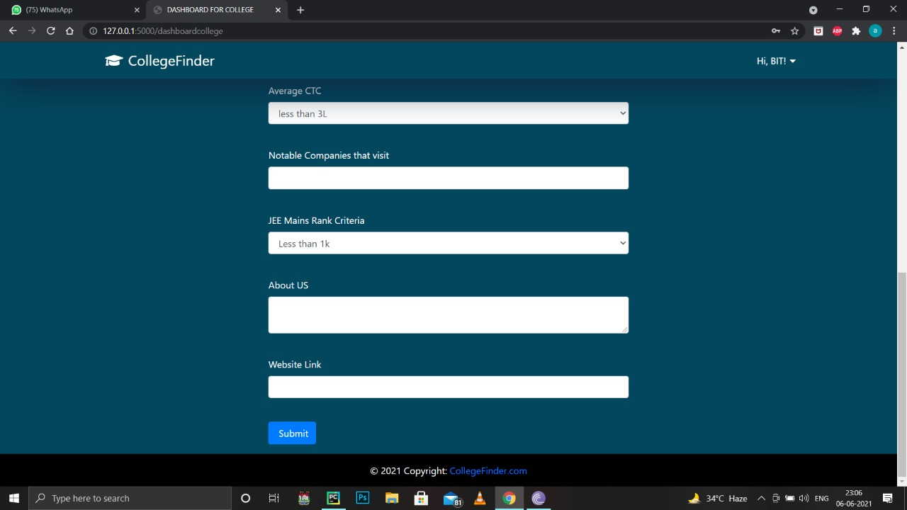

**Admin Module:**

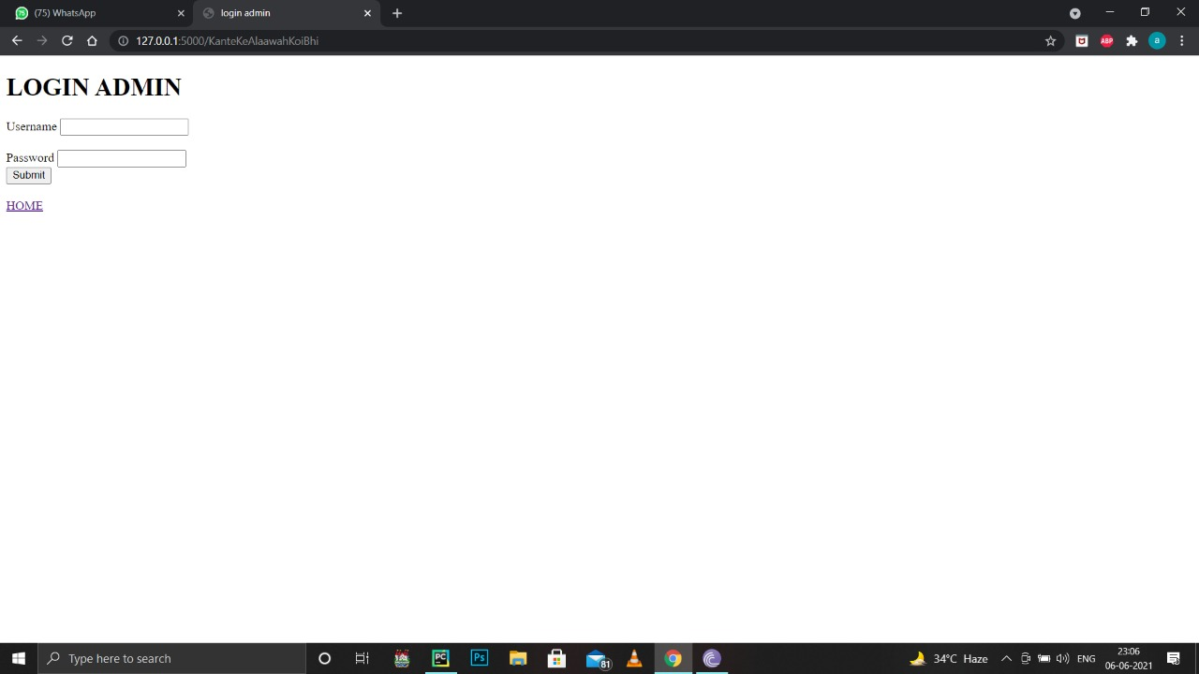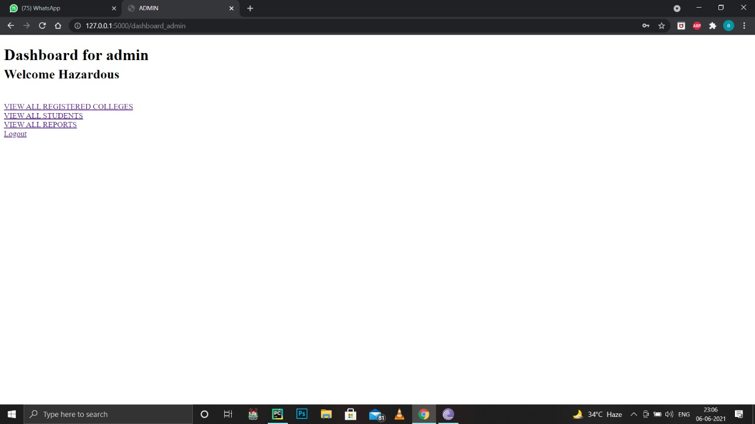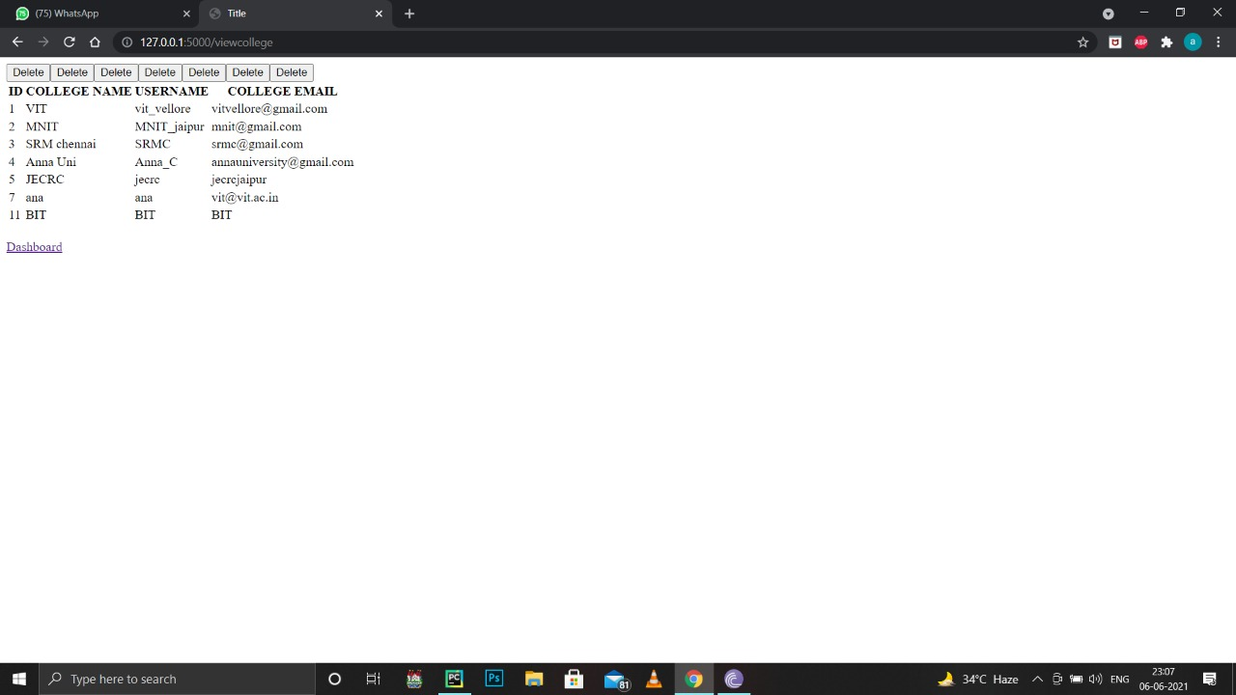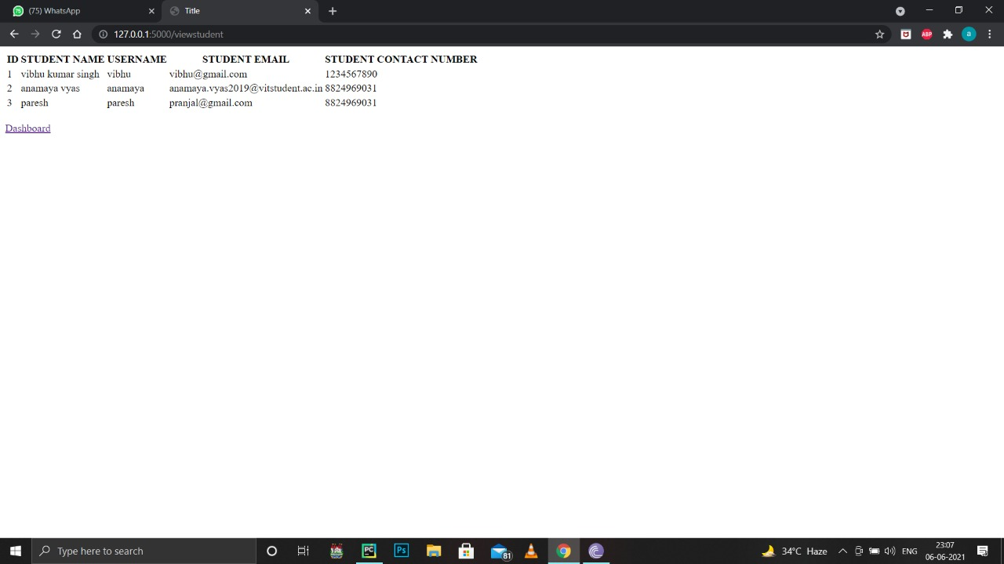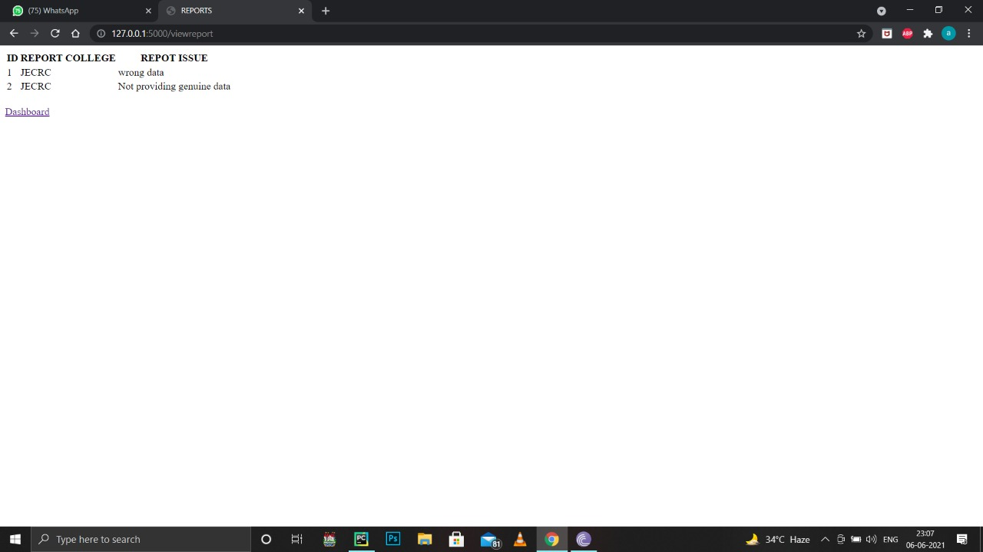

**5.2 Testing**

**5.2.1 Types of Testing**

Software Testing is a method to check whether the actual software product matches expected requirements and to ensure that software product is [Defect](https://www.guru99.com/defect-management-process.html) free. It involves execution of software/system components using manual or automated tools to evaluate one or more properties of interest. The purpose of software testing is to identify errors, gaps or missing requirements in contrast to actual requirements.

1. Unit Testing

It focuses on the smallest unit of software design. In this, we test an individual unit or group of interrelated units. It is often done by the programmer by using sample input and observing its corresponding outputs.

2. Integration Testing

The objective is to take unit tested components and build a program structure that has been dictated by design. Integration testing is testing in which a group of components is combined to produce output.

3. Smoke Testing

This test is done to make sure that software under testing is ready or stable for further testing

It is called a smoke test as the testing of an initial pass is done to check if it did not catch the fire or smoke in the initial switch on.

4. System Testing

This software is tested such that it works fine for the different operating systems. It is covered under the black box testing technique. In this, we just focus on the required input and output without focusing on internal working.

In this, we have security testing, recovery testing, stress testing, and performance testing

5.Performance Testing

It is designed to test the run-time performance of software within the context of an integrated system. It is used to test the speed and effectiveness of the program. It is also called load testing. In it we check, what is the performance of the system in the given load.

6.Object-Oriented Testing

This testing is a combination of various testing techniques that help to verify and validate object-oriented software. This testing is done in the following manner:

Testing of Requirements

Design and Analysis of Testing

Testing of Code

Integration testing

System testing

User Testing

**5.2.2 Test Cases**

**1.Student Registration**

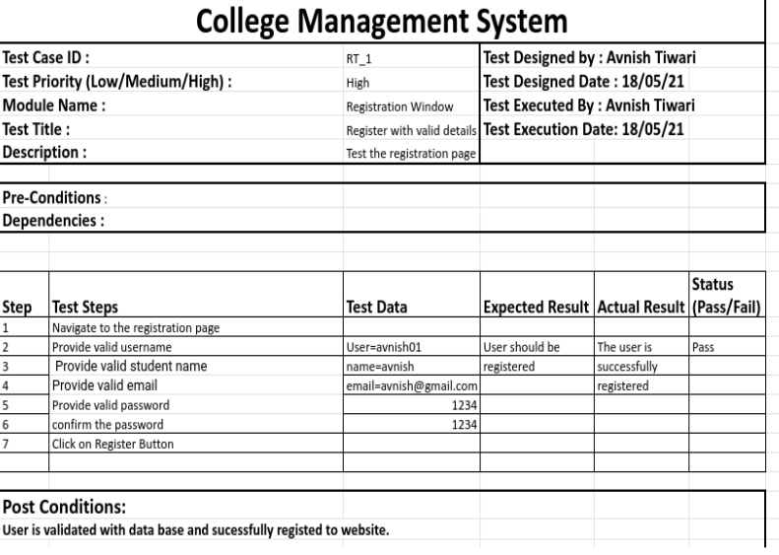

**2.College Registration**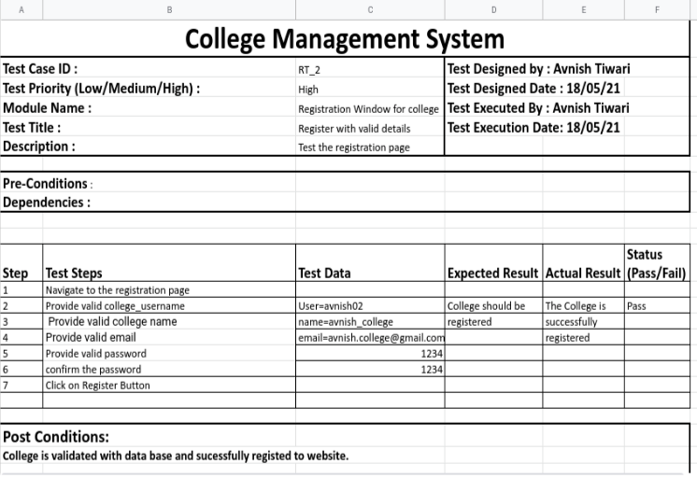

**3.Student Login**

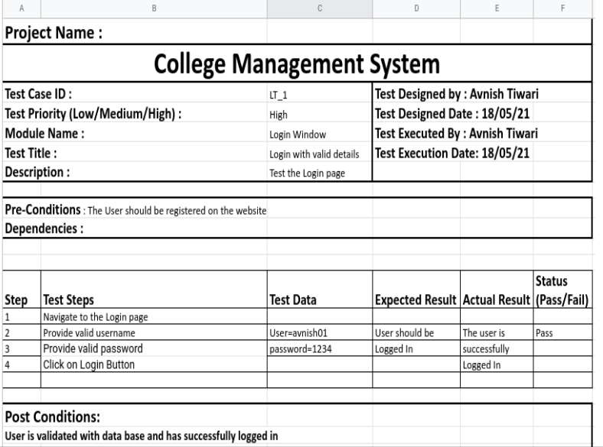

**4.College Login**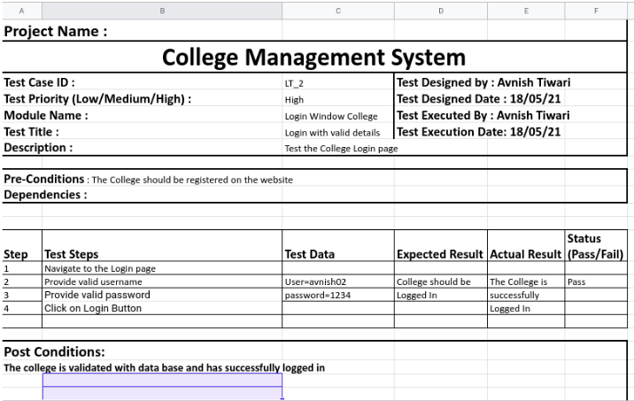

**5.College Dashboard**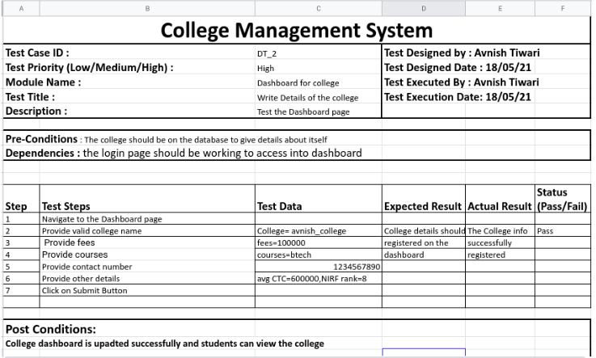

**6.Student Dashboard**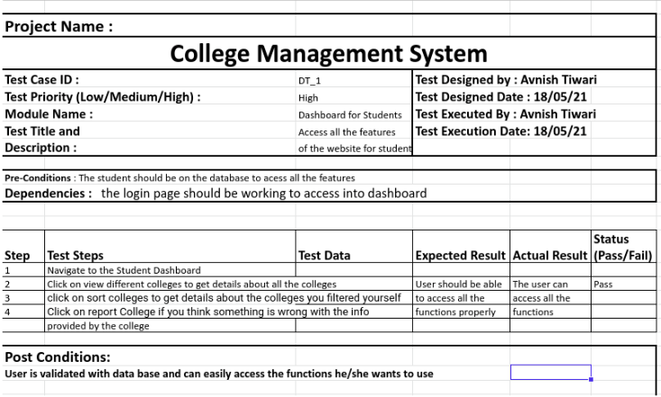

**7.Sort Colleges**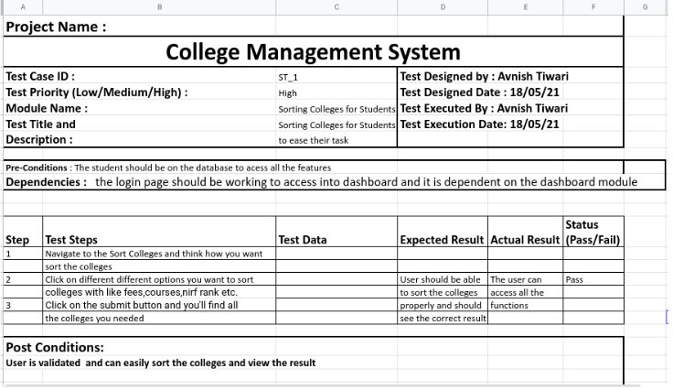

**8.Report Colleges**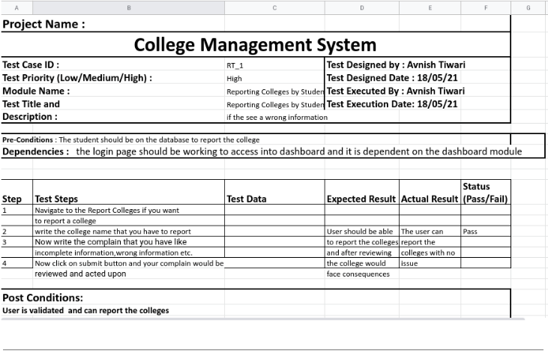

**6.Conclusion, Limitations and Scope for future Work**

**Conclusion:**

After completing the project, we can conclude that we have made an efficient and intelligent website that connects the colleges and students and provides a unique platform to the students who want to take admission after their 12th class.

Also, the colleges would also benefit as they would get a wider reach and many applications from all around the country.

**Limitations:**

Despite a fully functioning project we still lack a domain and web server for hosting to implement this project on a larger scale.

**Scope for Future Work:**

For the Future work we can collaborate with different colleges to get a greater reach and make the admission process easier.

Also, we can program a feature where the student can keep all his personal documents safe in a PDF format as they are needed every now and then in the admission process so it would make the admission process very less hectic.

Also, to implement on a larger scale we can scale it by using the web services.